1. ***Introduction/Business Problem***
   1. ***Idea***

By using the trending venues within the Foursquare location database, the user will find the best places where to shop in the city of Toronto, Canada

* 1. ***Audience***

Fashion/shopping addicted always lookin for the latest novelties. This tool would allow them to forecast what is growing more and more popular before it becomes too common. This report can also serve as a source of useful information for anyone who wishes to open a store in the best areas of Toronto in terms of traffic, in order to get, hopefully, incremental and higher reach.

1. ***Data***
   1. ***The main source: Foursquare***

The main source of data for this project has been the Foursquare database. Particularly, the Foursquare platform has been used in the following ways:

* To get trending places, meaning the ones with the higher foot traffic at a certain point of the day. However, due to the scarcity of results given back by Foursquare, as well as anomalies encountered while dealing with the code (check the next section), this database has revealed to be unreliable in many ways.
* To get and display the location of all the current shopping stores in the city of Toronto.
  1. ***Some additional pieces of information***

The data for this project could have also come from the following sources:

* The Wikipedia page for the postal codes in the city of Toronto, which will allow to create a dataframe containing postalcode, borough and neighborhood

<https://en.wikipedia.org/wiki/List_of_postal_codes_of_Canada:_M>

* An csv file containing latitude and longitude for each of the already mentioned postal codes

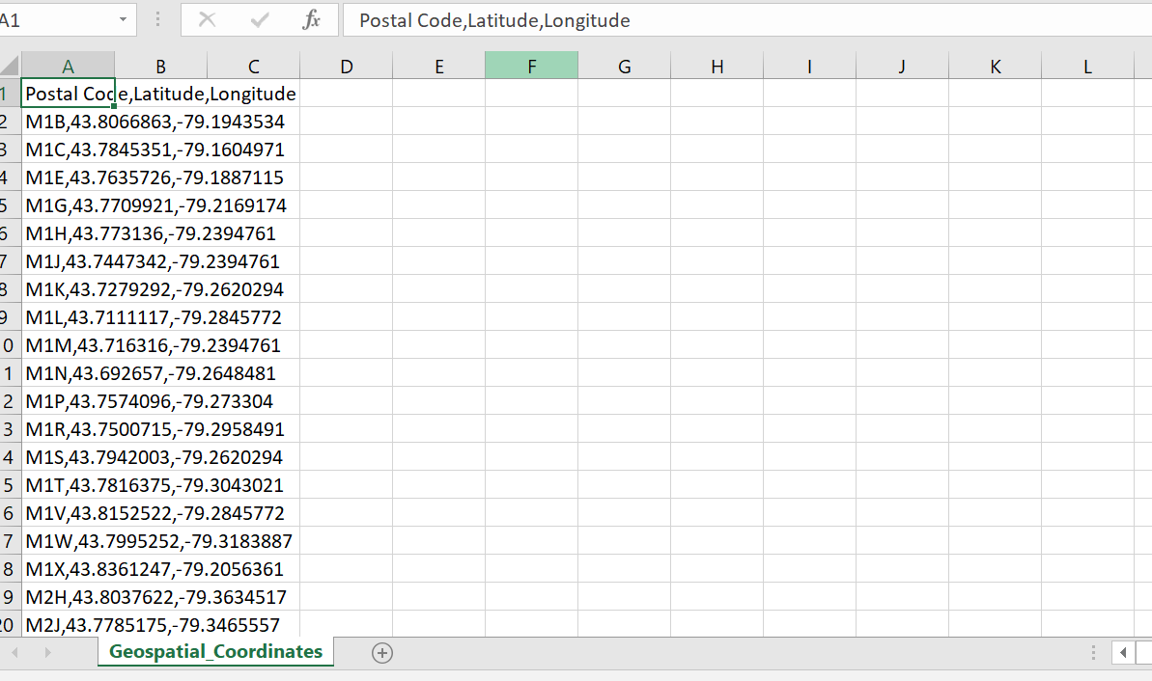

1. ***Methodology***

The work proceeded in the following ways:

* By getting a visualization of the trending venues in a certain time of the day. In the case of the figure shown, it’s at 11:33 in the morning. However, due to anomalies encountered in the implementing of the code (meaning, the code is correct and verified but it doesn’t get any trending venues, eventhough by checking on foursquare.com it is possible to visualize one trending place. This is an issue with the trending call that has been already frequently reported in the discussion forum of coursera), the image shown here comes from the foursquare search engine directly:

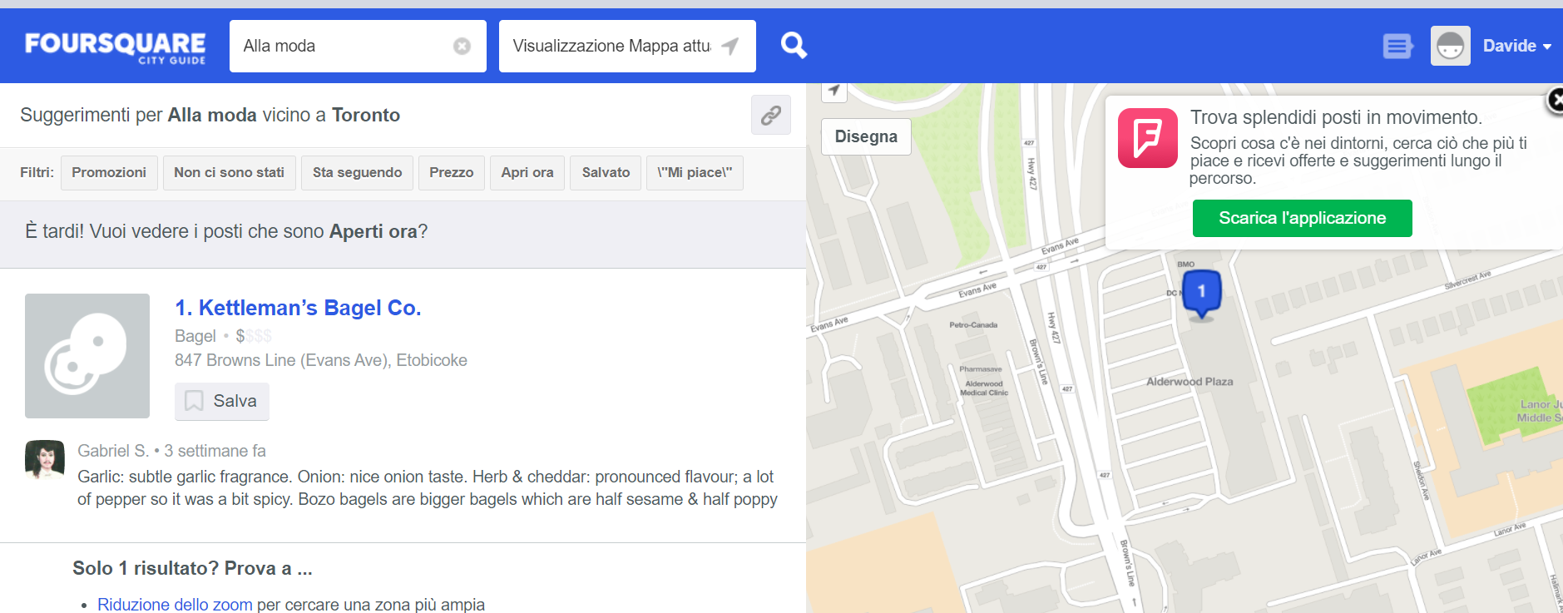

* By getting a visualization of the shopping centers in the city of Toronto.

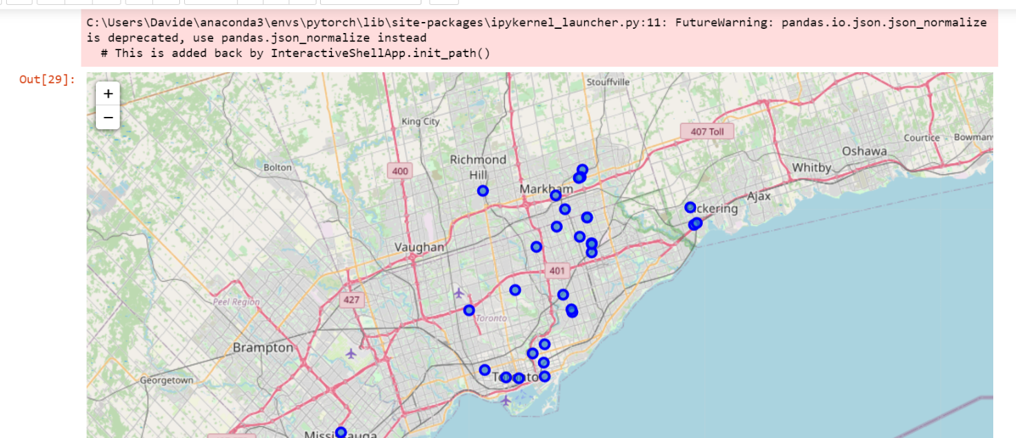

* By comparing the shopping centers location with the trending venues location. This would allow to infer which are the shopping places that are more likely to experience a favourable effect from the already high foot traffic in the nearby area

1. ***Results***

By comparing the first map with the second it is possible to conclude that, for what concerns the early morning, Alderwood would be the area where:

* The shops visualized in the second map can benefit from a higher foot traffic
* It would be advisable to open a shop, especially if the kind of goods sold are meant to target a morning audience

1. ***Discussion***

Based on the remarks at point 4, it would be recommended for both an experienced shopper or a potential business owner, to consider the Alderwood area for any morning activity of interest.

1. ***Conclusion***

At the end of this report, my considerations as a developer are:

* Not to rely extensively on the trending call, since it is likely not to give back the actual trending venues available on Foursquare, and even if it is, the number of venues available is so scarce that it doesn’t represent a reliable source of information in terms of quantity
* In order for this report to be of any more reliability, it would be required to look for another way to extract information about foot traffic, as well as a higher number of observations spanned across the whole day, to check how trends would change throughout it, and these observations should be repeated across many days as well in order to represent a significant sample.